Geranium Instant Report

## Instant Report for ArcNet domain.

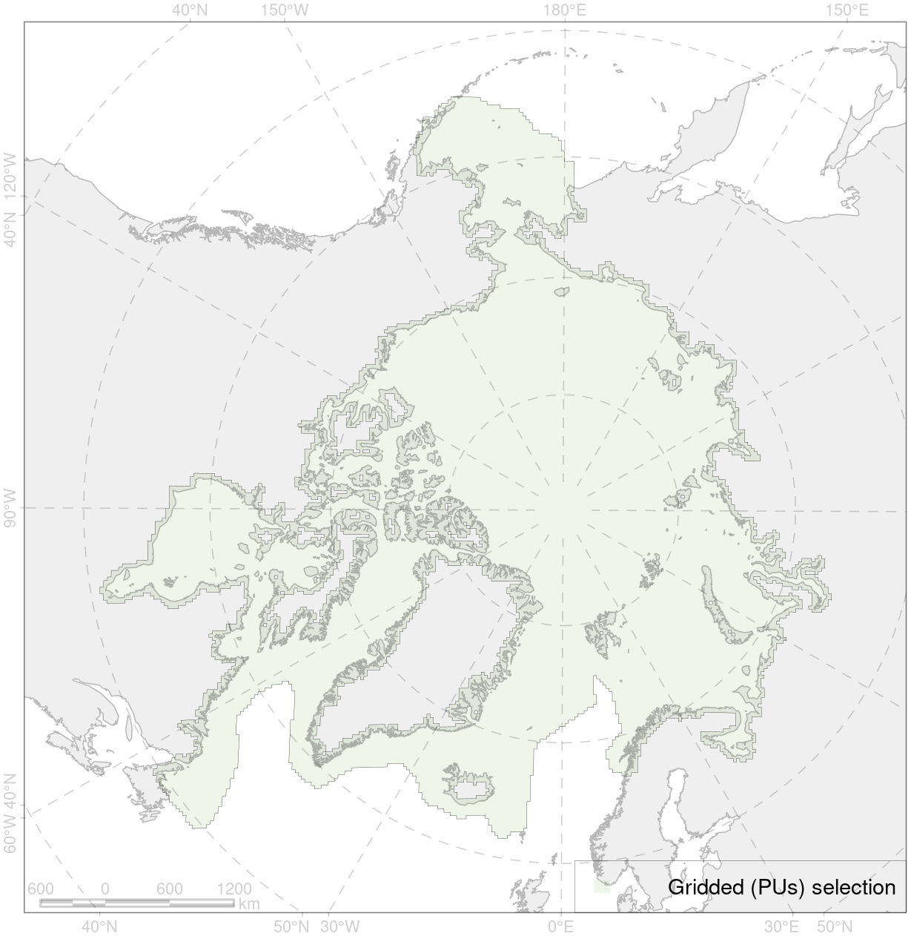

Figure 1: Selected Area

Basic statistics of selected area:

Table 1: Basic statistics

| No of Pus | No of CFs | Total Area, km2 | Total Area, PUs, km2 | Terrestrial Area, PUs, km2 | Marine Area, PUs, km2 |
| --- | --- | --- | --- | --- | --- |
| 22678 | 705 | 0 | 20410200 | 3549222 | 16860978 |

Concern Indexes:

Table 2: Concern Indexes

| RSC-PU SR, % | ROC-PU MNSR, % | RSC-AOI SA, % | ROC-AOIMNSA, % |
| --- | --- | --- | --- |
| 100 | 100 | 19.3 | 22.5 |

Pressure Indexes Activity Indexes:

Table 3: Pressure Indexes Activity Indexes

| ROIP-PU CAPR, % | ROIP-AOI CAP, % | AA-PU AAR, % |
| --- | --- | --- |
| 100 | 4.7 | 100 |

Relative Overall Concern Level by Month (ROC-M) Conservation Concern Level by Month:

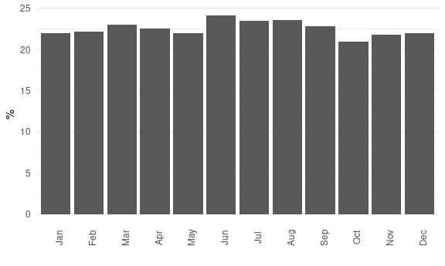

Figure 2: Relative Overall Concern Level by Month (ROC-M) Conservation Concern Level by Month

Relative Overall Concern Level by Activity (ROC-IA) Conservation Concern Level by Activity:

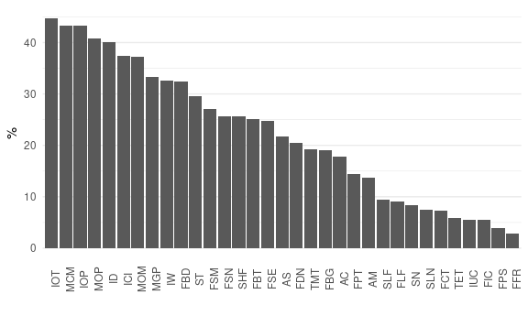

Figure 3: Relative Overall Concern Level by Activity (ROC-IA) Conservation Concern Level by Activity

Table 4: List of Activities ordered by Relative Overall Concern Level by Activity Conservation Concern Level by Activity

| Activity ID | Activity | ROC-IA MNSA, % |
| --- | --- | --- |
| IOT | Coastal Oil Terminals | 44.7 |
| MCM | Coastal Onshore Mining | 43.3 |
| IOP | Underwater Oil & Gas Pipelines | 43.2 |
| MOP | Offshore Oil & Gas-condensate Production | 40.8 |
| ID | Dredging | 40.1 |
| ICI | Coastal Infrastructure | 37.4 |
| MOM | Other Offshore Mining | 37.2 |
| MGP | Offshore Gas Production | 33.4 |
| IW | Offshore Wind Farms | 32.7 |
| FBD | Dredge Fishing | 32.4 |
| ST | Tankers carrying oil and other petrochemicals | 29.5 |
| FSM | Seaweed Mowing | 27.2 |
| FSN | Snurrevad Fishing | 25.7 |
| SHF | Cargo Vessels - Heavy Fuel Oil | 25.6 |
| FBT | Bottom Trawling | 25.2 |
| FSE | Seine and Stationary Seine Fishing | 24.8 |
| AS | Seaweed Farms | 21.7 |
| FDN | Drift Net Fishing | 20.5 |
| TMT | Mass tourism | 19.2 |
| FBG | Bottom Gillnets Fishing | 19.0 |
| AC | Finfish Farms | 17.8 |
| FPT | Pelagic Trawling | 14.4 |
| AM | Shellfish Farms | 13.7 |
| SLF | Cargo Vessels – Light Fuel Oil | 9.4 |
| FLF | Longline Fishing | 9.0 |
| SN | Nuclear-powered Vessels | 8.4 |
| SLN | Cargo LNG-powered Vessels | 7.4 |
| FCT | Pot and Trap Fishing | 7.3 |
| TET | Ecotourism | 5.9 |
| IUC | Submarine Communication Cables | 5.5 |
| FIC | Invertebrates Collection by Divers | 5.4 |
| FPS | Purse Seine Fishing | 4.0 |
| FFR | Pole and Line Fishing | 2.8 |

CF list by Concern:

Table 5: CF list by Relative Overall Concern Level Concern

| CF ID | CF Name | ROC-CF MNSCF, % |
| --- | --- | --- |
| 2055 | Steller sea lion (*Eumetopias jubatus*) critical habitats | 91.8 |
| 2057 | Steller sea lion (*Eumetopias jubatus*) haulouts with buffer | 87.3 |
| 9021 | Polar bear (*Ursus maritimus*), Baffin Bay subpopulation, denning grounds | 86.9 |
| 9022 | Polar bear (*Ursus maritimus*), Chukchi Sea subpopulation, denning grounds | 86.9 |
| 9023 | Polar bear (*Ursus maritimus*), Davis Strait subpopulation, denning grounds | 86.9 |
| 9024 | Polar bear (*Ursus maritimus*), East Greenland subpopulation, denning grounds | 86.9 |
| 9025 | Polar bear (*Ursus maritimus*), Foxe Basin subpopulation, denning grounds | 86.9 |
| 9026 | Polar bear (*Ursus maritimus*), Gulf of Boothia subpopulation, denning grounds | 86.9 |
| 9027 | Polar bear (*Ursus maritimus*), Kane Basin subpopulation, denning grounds | 86.9 |

Top CFs by Coverage Cover (all with cover above 20%):

Table 6: Top CFs by Coverage Cover

| CF ID | CF Name | Coverage Cover, % | ROC-CF MNSCF, % |
| --- | --- | --- | --- |
| 1002 | Walrus (*Odobenus rosmarus rosmarus*) summer grounds, Canadian Arctic Archipelago | 100 | 24.0 |
| 1003 | Walrus (*Odobenus rosmarus rosmarus*) winter grounds, Canadian Arctic Archipelago | 100 | 19.8 |
| 1004 | Walrus (*Odobenus rosmarus rosmarus*) summer grounds, East Greenland | 100 | 24.2 |
| 1005 | Walrus (*Odobenus rosmarus rosmarus*) winter grounds, Spitsbergen and FJL region | 100 | 27.6 |
| 1006 | Walrus (*Odobenus rosmarus rosmarus*) summer grounds, Spitsbergen and FJL region | 100 | 26.7 |
| 1007 | Walrus (*Odobenus rosmarus rosmarus*) haulouts, Pechora and Kara region | 100 | 68.1 |
| 1008 | Walrus (*Odobenus rosmarus rosmarus*) haulouts, Spitsbergen and FJL region | 100 | 58.7 |
| 1009 | Walrus (*Odobenus rosmarus rosmarus*) summer grounds, Pechora and Kara region | 100 | 21.3 |
| 1010 | Walrus (*Odobenus rosmarus rosmarus*) winter grounds, Pechora and Kara region | 100 | 21.1 |
| 1011 | Walrus (*Odobenus rosmarus rosmarus*) haulouts, Nunavut and West Greenland | 100 | 61.4 |
| 1012 | Walrus (*Odobenus rosmarus rosmarus*) haulouts, East Greenland | 100 | 65.4 |
| 1013 | Walrus (*Odobaenus rosmarus divergens*) Laptev population, haulouts | 100 | 78.0 |
| 1014 | Walrus (*Odobaenus rosmarus divergens*) Laptev population, winter grounds | 100 | 37.6 |
| 1015 | Walrus (*Odobaenus rosmarus divergens*) Pacific population, whelping grounds | 100 | 41.5 |
| 1016 | Walrus (*Odobaenus rosmarus divergens*) Pacific population, feeding grounds | 100 | 50.7 |
| 1017 | Walrus (*Odobaenus rosmarus divergens*) Pacific population, haulouts | 100 | 58.9 |
| 1018 | Walrus (*Odobaenus rosmarus divergens*) Pacific population, summer-autumn grounds | 100 | 33.7 |
| 1019 | Walrus (*Odobaenus rosmarus divergens*) Pacific population, winter grounds | 100 | 27.8 |

Можем ли мы сделать два разных отчёта в зависимости от того, что выбрано Concern или OIP? По аналогии таблицы и диаграммы?